**Calculations**

1. CAC for the first 12 month:   
   **Are you using direct or indirect sales?**We are using indirect selling. Our product will accomplish on online platform.   
     
     
   **Are you using online advertisement?**  
   I looked up, how Google Ads are working. It is possible to set a region in the world, which you want to influence with your product. I could give the website of my startup and after that I could choose which text will be appear above my link. Google suggested me an Advertisement for 5000 ft/day. So it is 31*5000= 155000 ft in a month. Google garantues that the ad will reach 1450-2420 (click onto the ad link) people, who are new potential costumers. Hopefully each month will end up with 500- 1000 new costumers.CAC= 155000 ft /500= 310 ft or 155000 ft/1000 =155 ft. So the result will changing between 155 ft and 310 ft,if I did not underestimate the number of the new users. It depends on the keywords and how we positioning our target group.   
     
   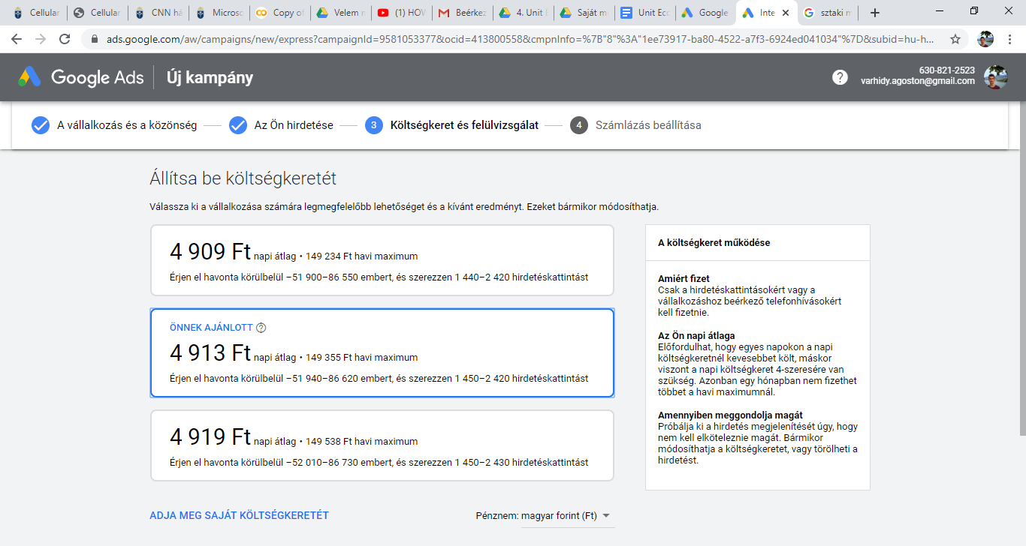  
     
   **What is the success rate of your outreach**
2. **strategy?**

* **Firstly, we should focus on the marketing campaigs (like google or other ads, exploring concurrent companys, collact info about the demands of people -> integrate into the strategy, emails with partners our, future supporters)**
* **Finding the target, positioning our product (employee, companies, diasbled people)**
* **This is the time to convince our target group that our product is the best  
  (demo verzió valamilyen feature-re, suggestions( minden honlapon szokott ilyen lenni), valamilyen ingyenes “ajándék” és ezáltal az email címüket megszerezve, levezőlista célzottan az érdeklődőknek)**
* **Sales (this is just the last step)**

**3.)How much it will cost you to acquire:**

**■ B2B Service: 10 new client:** If I calculate only with Google Ads:1550 -3100 ft

**■ B2C Consumable: 1,000 new customers:** 155000-310000 ft.   
 Facebook also offers a chance to make advertisements. It is like the Google ads, we can   
 decide how much we want to spend. The minimum price is 400 ft, and the maximum is

150000 ft/day. Our advertisement can reach more people, if it lasts more than 4 days.   
 In Facebook I could not find any options, which garauntes me the number of clicks. So it is   
 pretty hard to estimate how much 10 or 1000 new costumers acquires.